Milestone 2 Automated Feature Extraction and Matching
Wei-Yuan Su, Kehao Xu
https://github.com/Wayne0758/Computer-Vision
SuperPoints:
Automated Feature Extraction:
- Points selection of IMG_1223(A):
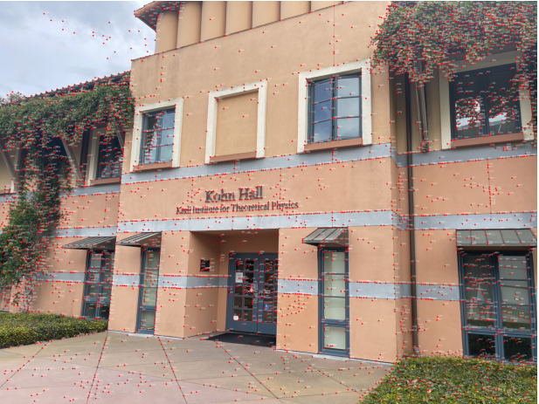
- Points selection of IMG_1224(B):
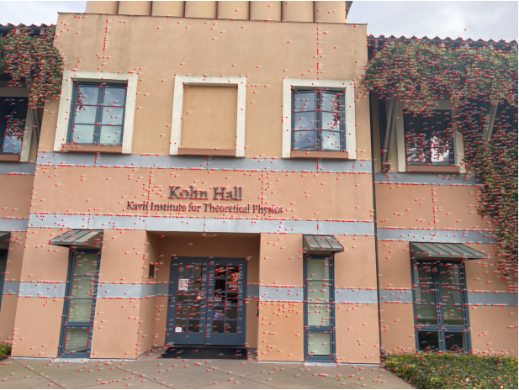
- Points selection of IMG_1226(C):
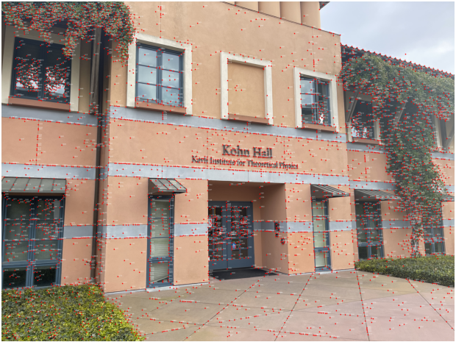
Homography Estimation and Validation:
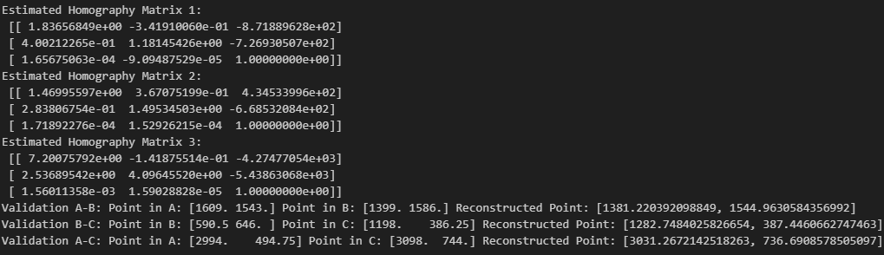
Fundamental Matrix and Epipolar Geometry:
- F matrices
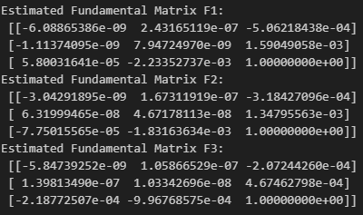
- Visualization of epipolar lines
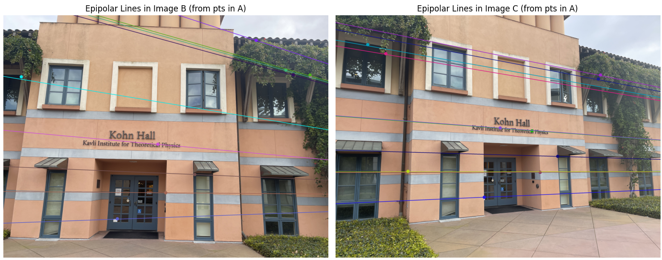
- Visualization of epipolar lines of new points
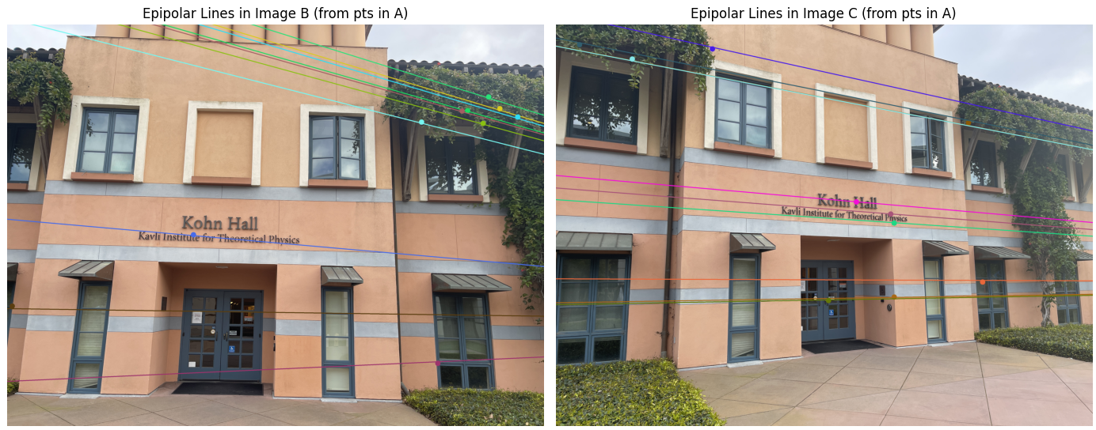
Observation:
- The mapped points generally aligned well on planar surfaces.
- Small deviations occurred around non-planar structures, which is expected due to the homography assumption.
- Most points aligned closely to their corresponding epipolar lines, validating the estimated F matrices.
- Some mismatches appeared due to noise and repetitive patterns.
DISK:
Automated Feature Extraction:
- Points selection of IMG_1223(A):
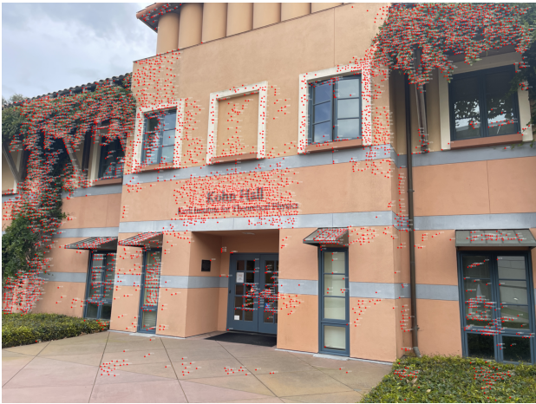
- Points selection of IMG_1224(B):
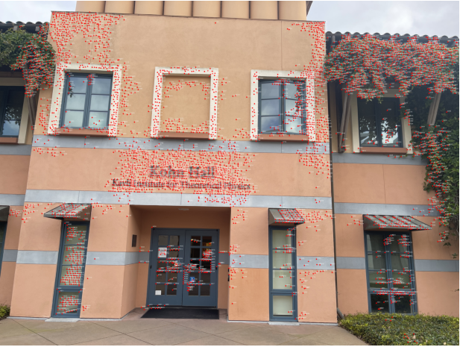
- Points selection of IMG_1226(C):
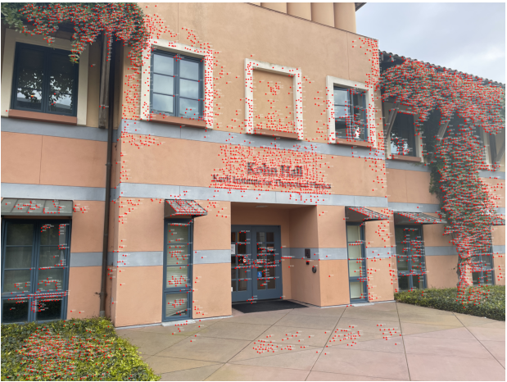
Homography Estimation and Validation:
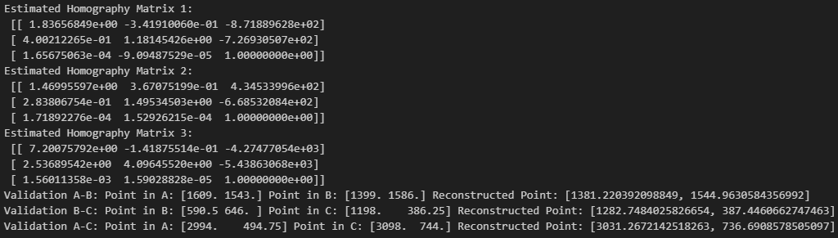
Fundamental Matrix and Epipolar Geometry:
- F matrices
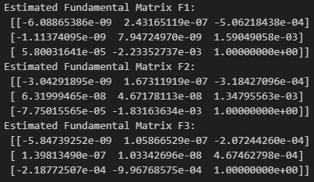
- Visualization of epipolar lines
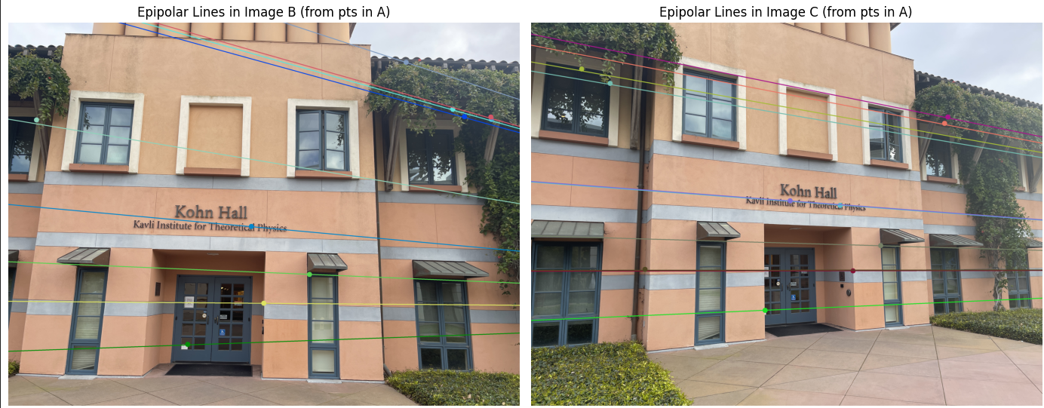
- Visualization of epipolar lines of new points
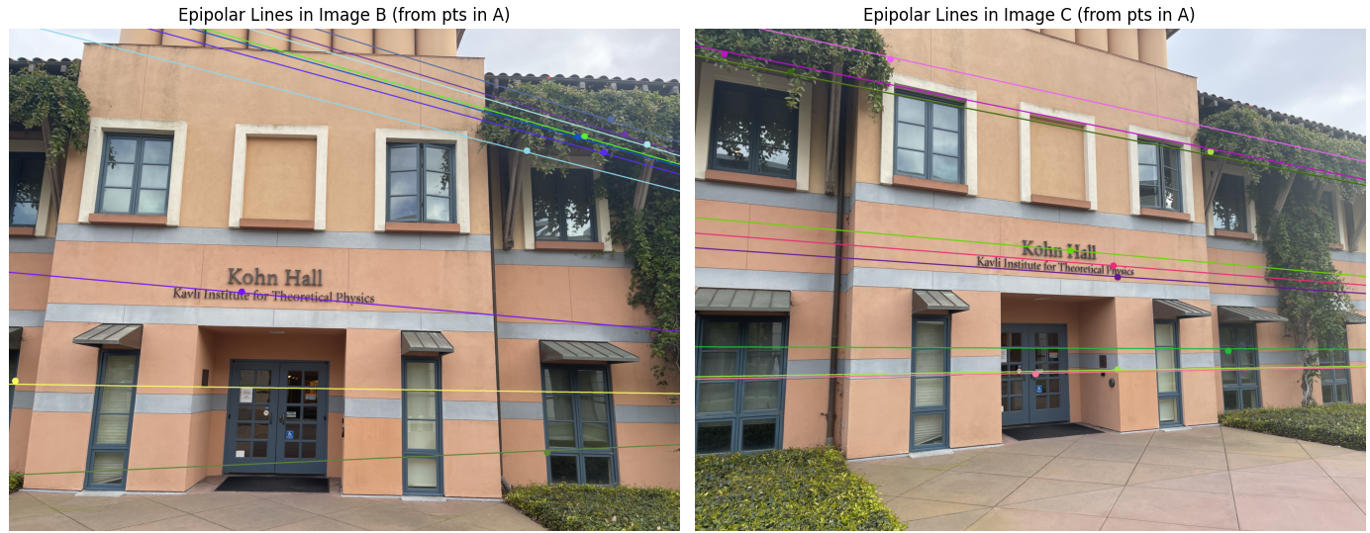
Observation:
- DISK showed denser keypoints in textured regions.
- Mapped points showed good local accuracy, but occasionally missed larger structural alignment
- DISK produced more matches overall, but slightly noisier.
- Geometric verification via RANSAC helped prune mismatches effectively.
SIFT:
Automated Feature Extraction:
- Points selection of IMG_1223(A):
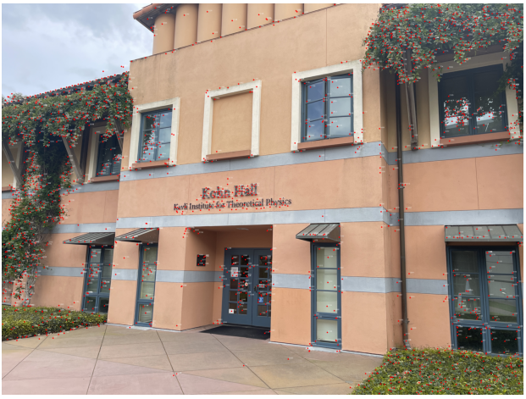
- Points selection of IMG_1224(B):
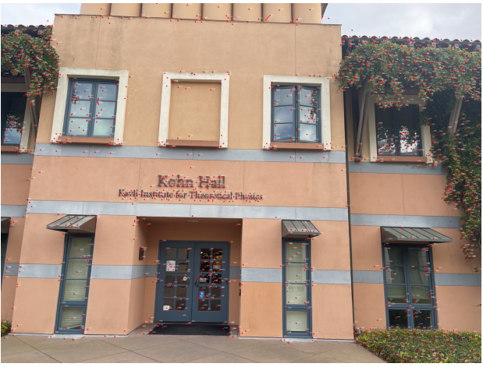
- Points selection of IMG_1226(C):
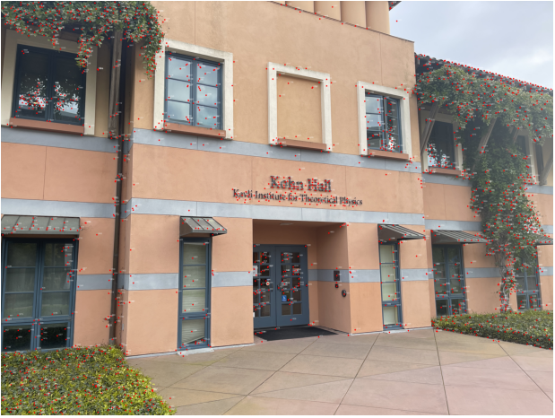
Homography Estimation and Validation:
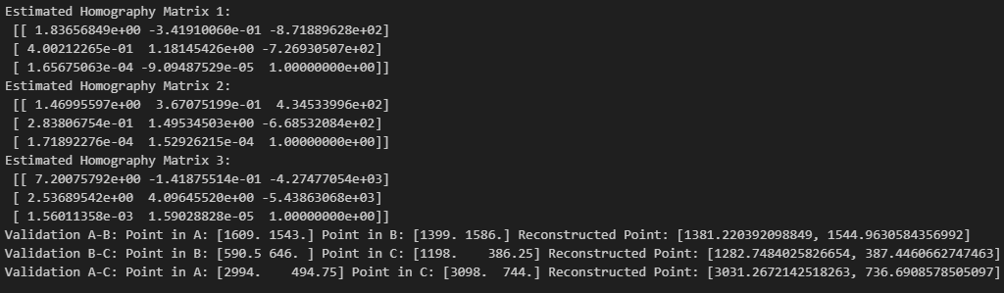
Fundamental Matrix and Epipolar Geometry:
- F matrices
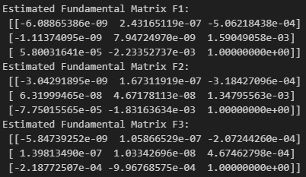
- Visualization of epipolar lines
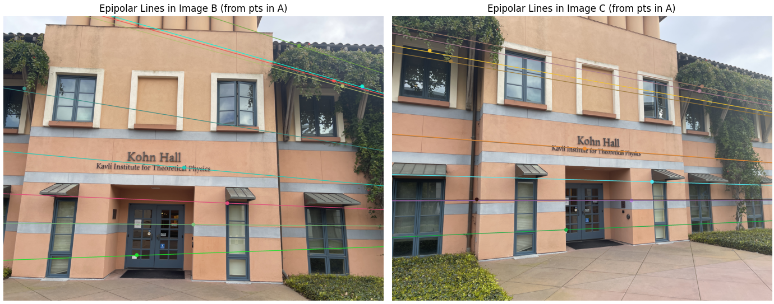
- Visualization of epipolar lines of new points
` 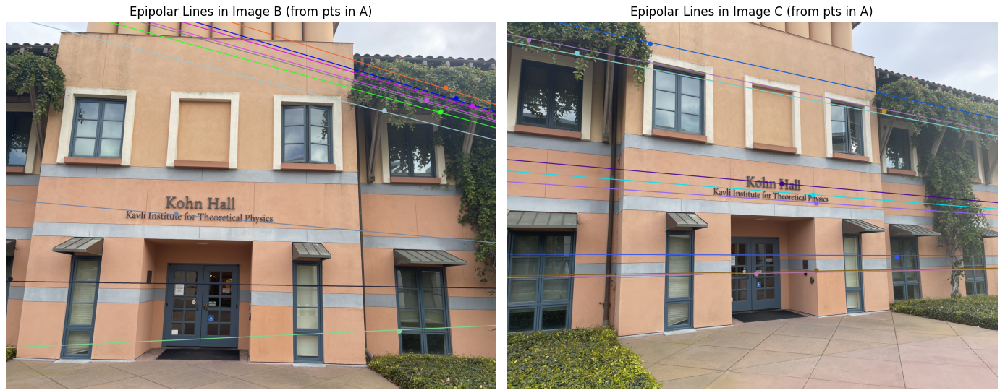
Observation:
- SIFT detected stable keypoints especially in textured and corner regions.
- Homography mapping was very reliable for planar areas.
- Very strong alignment between points and epipolar lines.
- Few outliers remained after RANSAC pruning.
Methods Comparison:
- Disk: Faster and more lightweight, but produced noisier matches.
- SIFT: More computationally expensive but very reliable for textured scenes.
- SuperPoint: Balanced speed and robustness well, good for general purposes.
Conclusion:
In this milestone, we automated feature extraction and matching using SuperPoint, Disk, and SIFT. Homography estimation and epipolar geometry validation showed that SuperPoint and SIFT provided the most reliable matches. Disk detected more features but introduced more noise. RANSAC geometric verification effectively removed incorrect matches. These automated pipelines pave the way for scalable 3D reconstruction and structure-from-motion tasks.

